**Project Overview**

The Map Viewer Project is an interactive web-based application designed to display geographical maps, enabling users to explore locations, zoom in/out, search for addresses, and interact with map layers. This project leverages technologies such as OpenLayers or ArcGIS for rendering maps, providing a responsive and user-friendly experience. It can be used for educational purposes, urban planning, or personal navigation tools. The following sections describe key components and features, illustrated with screenshots.

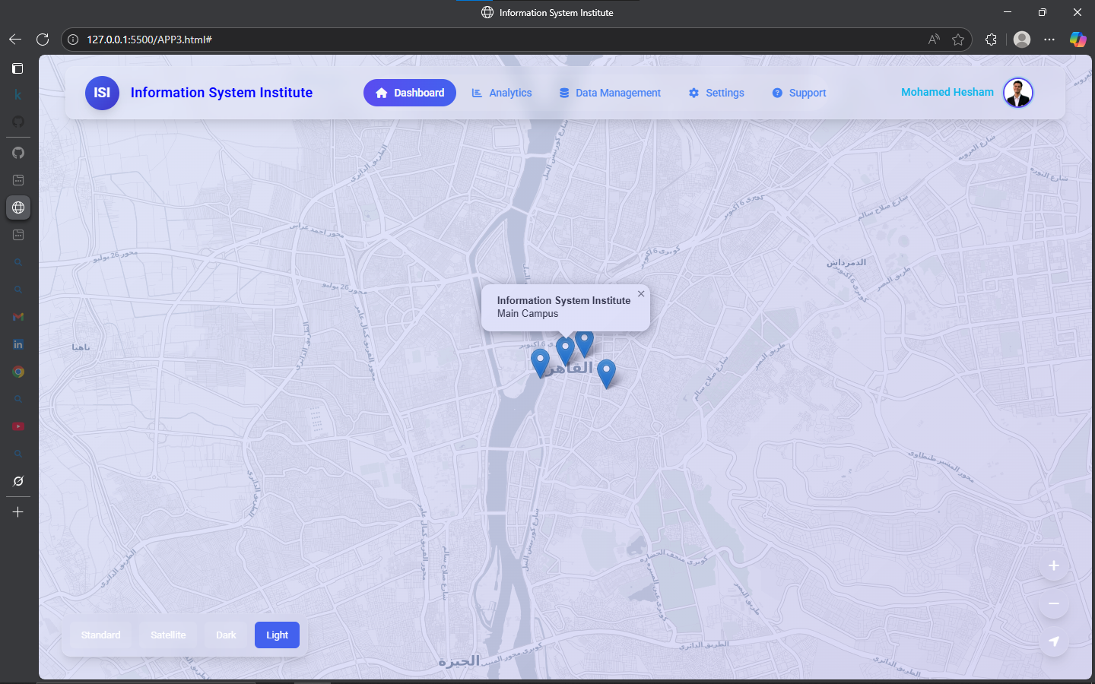

## Layer Selection and Addition

Here, the interface for adding and managing map layers is depicted. Users can select from various data sources, like satellite imagery or street maps, to overlay on the base map for customized views.

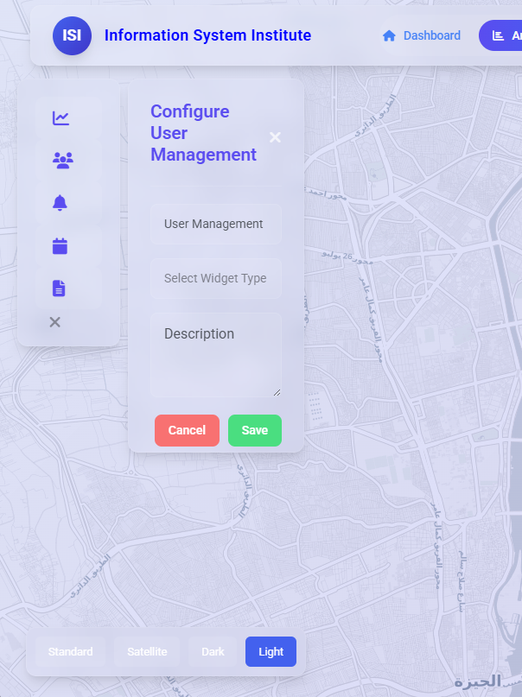

This demonstrates the zoom and panning capabilities, with smooth transitions for detailed views of areas like cities or landmarks. Figure 5: Zoomed-In Map Example

